Brain Injury Association of Virginia

Virginia Alliance of Brain Injury Service Providers

2023 Legislative Needs Statement

**WHAT:**

*$1,125,000 to create a “Housing Specialist” position at each state funded community based BI program*

**PATRONS AND ITEM NUMBERS:**

**WHY:**

* Despite facing the same needs as those with intellectual and developmental disabilities, people with brain injury have little to no residential service options available to them within the Commonwealth due to a lack of waiver supports.
* The shortage in housing and support options for individuals with disabilities has reached crisis proportions; 41% of the people who called the Brain Injury Association of Virginia (BIAV) last year told us housing was one of their top 3 needs.
* The BIAV has seen a 60% increase in the number of calls we receive for housing related assistance; 66% of state funded brain injury programs report an increase in the calls they receive from individuals searching for the resource.
* Housing is known to be one of the primary social determinants of health, and affordable, accessible, and appropriate housing can be life-saving.
* Staff are needed at community based-brain injury programs to liaise with local housing entities, represent the needs of the brain injury community in housing related conversations, and work with their clients to obtain the necessary housing supports and/or develop independent living skills to maintain clients safely and stably in the community.
* As the brain injury community is just beginning to develop capacity in the area of housing, and as we will be starting behind several other advocacy organizations in terms of our tenure and experience in this service area, we feel these positions will be critical to our ability to effectively serve person with brain injury.

**HOW:**

Through a DARS Appropriation and existing contract processes, 9 existing community based brain injury programs would receive funding for and be directed to establish a staff position to impact housing policy and facilitate housing placements and/or the development of independent living skills for their clients.

***“Over 50% of the referrals that come in are for housing and over 50% of my time as a case manager is spent working with people on housing.  I would imagine I am not the first CM to say those things, but the housing problem seems to be growing at an alarming rate while resources dwindle.”***

**SUCCESS STORY**

When R was referred to us, he had just come to Charlottesville and was living in his car; he had been in Richmond and was scared by all of the violence there. He received his TBI in a car accident, and also has mental health issues. He was on the wait list for a Section 8 voucher and struggling, and I was very concerned he would end up in the hospital or jail if he did not find housing.  Through some sort of divine intervention, he was awarded a voucher just a couple of months later.  We worked with him to find an apartment, used DARS funding to help him purchase needed items and move some other things from Richmond, and helped his landlord get him set up with the necessary online rent payment plan.  After moving into his apartment, his anxiety and overall mood greatly improved, and he was able to start working on other goals like access to health care, financial independence and finding a job.

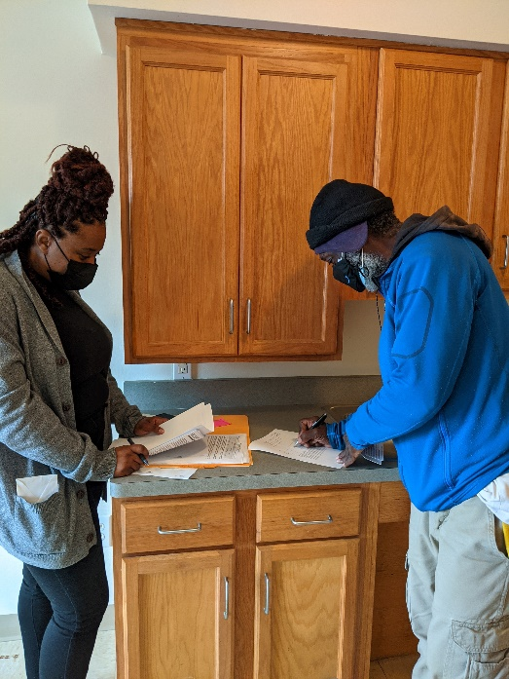 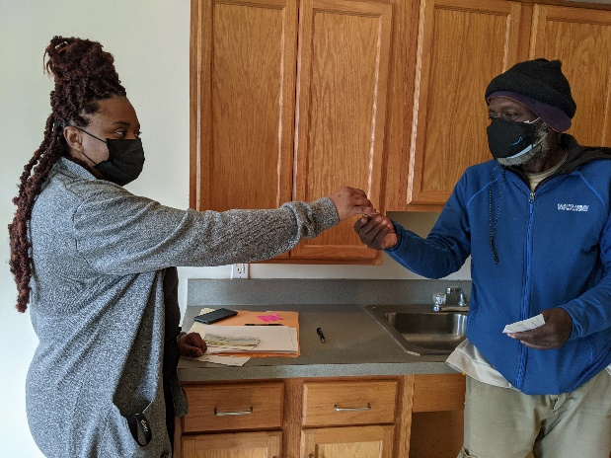

**TYPICAL CHALLENGE**

One consumer qualified for Section 8 housing during the pandemic, after 7-8 years on the waitlist. Because all of this happened during the pandemic, options were very limited, and he ended up in a mobile home park. The trailer he lives in is not level, and he’s been struggling with roaches.  He has tried to make complaints about his living situation through STEP-section 8 housing but hasn't gotten anywhere.  He is looking for a place to move but he has to have a 2 bedroom unit since he has a roommate and they are not married. There are certain areas he wants to avoid living in since he has been clean for years and doesn't want to fall back in with a bad crowd.  He also has to find a place that will accept his Section 8 housing voucher.  We’re exploring housing options with him with very little success.