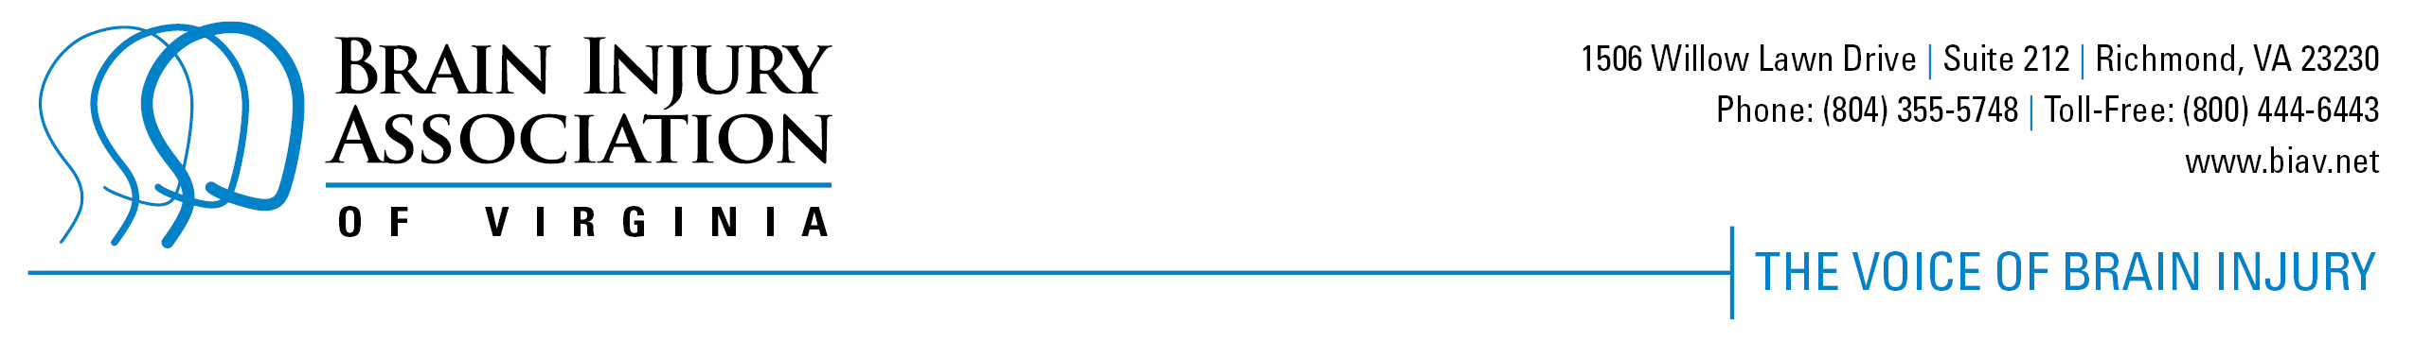

COMMONLY USED Acronyms & Terms

BIAV Programs:
ACBIS – Academy for the Certification of Brain Injury Specialists
BIRN – Brain Injury Resource Network
REACT – previous federal grant: Realizing Enhanced Access to Community Treatment. ACCESS – current federal grant: A Comprehensive Coordinated Entry to Services and Supports
I&R – Information and Referral

Boards/Councils:
CNI – Commonwealth Neurotrauma Initiative Trust Fund
VBIC – Virginia Brain Injury Council

State Agencies:
DBHDS – Department of Behavioral Health and Developmental Services
DJJ – Department of Juvenile Justice
DOE – Department of Education
DMAS – Department of Medical Assistance Services
DARS – Department for Aging and Rehabilitative Services
DSS - Department of Social Services
DVS – Department of Veterans Services
VDH – Virginia Department of Health

Organizations:
BIAA – Brain Injury Association of America
CSB – Community Services Board
VABISP – Virginia Alliance of Brain Injury Services Providers (also known as the Alliance)

